Q01.

public class Q01 {  
 public static void main(String[] args) {  
// Print the following array using for loop and foreach loop and get the sum of all the values  
// stored in the Num array.  
 int Num[] = {40, 28, 10, 81, 23, 45, 47, 18, 76, 64};  
  
 int sum = 0;  
 for (int i = 0; i < Num.length; i++) {  
 sum += Num[i];  
 }  
 System.*out*.println("Sum by for loop is " + sum);  
  
  
 sum = 0;  
 for (int i : Num) {  
 sum += i;  
 }  
 System.*out*.println("Sum by for each is " + sum);  
  
 }  
 }

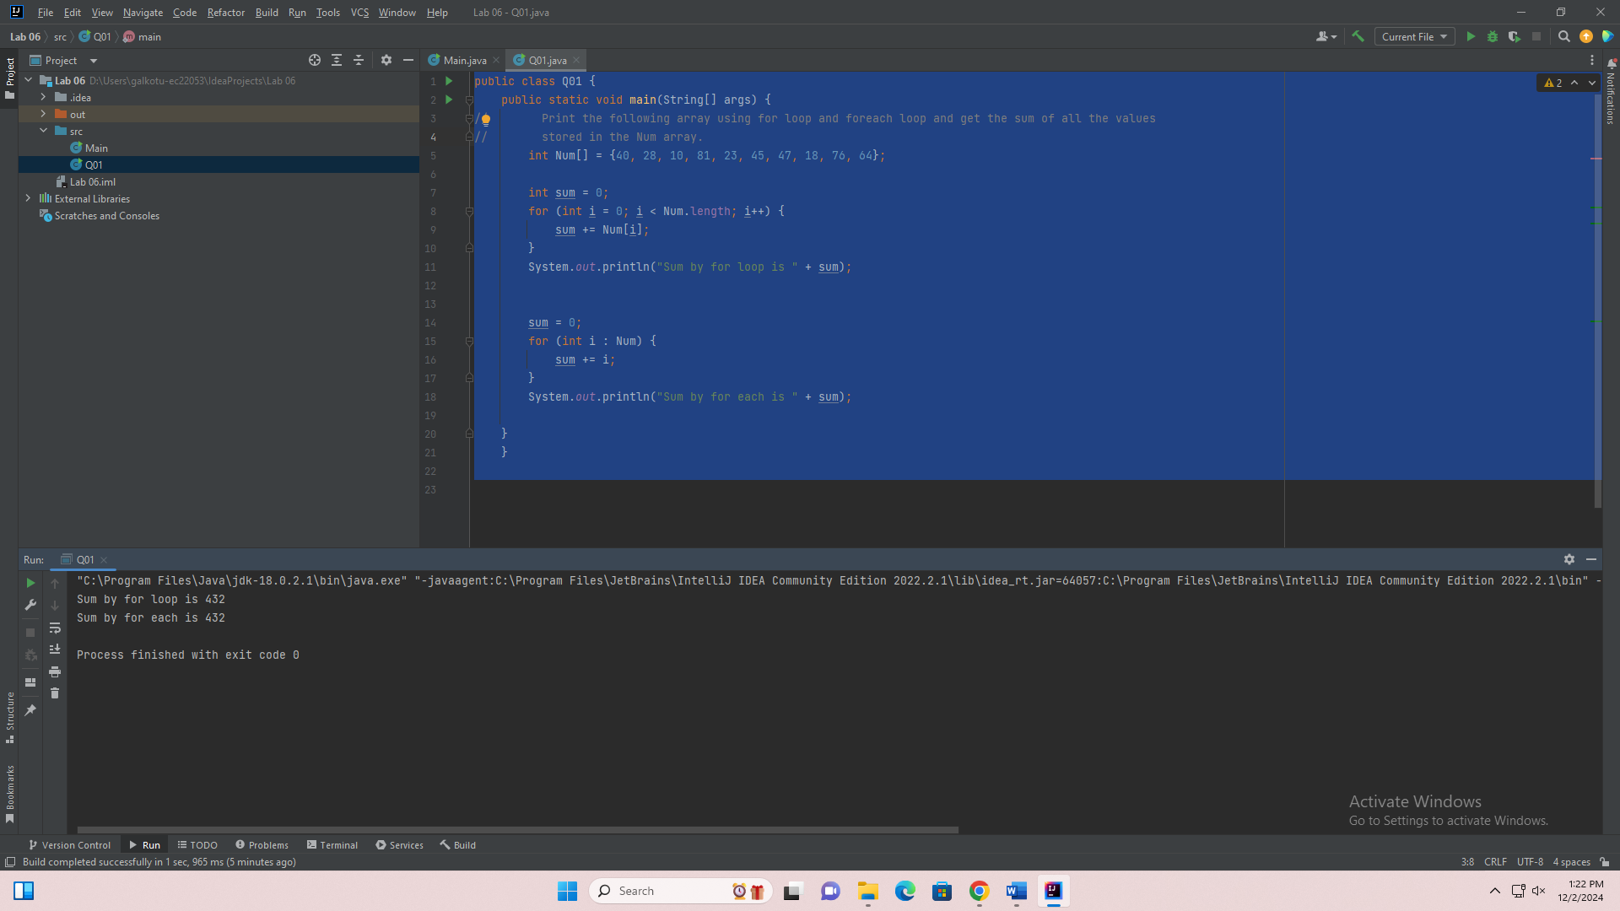

Q02.

public class Q02 {  
 public static void main(String[] args) {  
// 2. The two-dimensional array below contains the weights of students in 4 groups:  
// Write a Java program to compute the average weight of students for each group and display  
// the results in the format:  
// Group 1 Average Weight: 50.83  
// Group 2 Average Weight: 58.20  
// Group 3 Average Weight: 52.20  
// Group 4 Average Weight: 57.17  
 double[][] weights = {{54.5, 50, 48}, {43, 56.5, 67, 65.5, 59}, {45, 55, 63, 45.5, 54.5}, {66, 49.5, 56}};  
 int groupNo = 1;  
  
 for (double[] group:weights) {  
 double sum=0;  
 double avg=0;  
 for (double s:group) {  
 sum +=s;  
 }  
 System.*out*.print("Group "+groupNo+" Average Height: " );  
 System.*out*.printf("%.2f\n",(sum/ group.length));  
 groupNo++;  
  
 }  
  
 }  
}

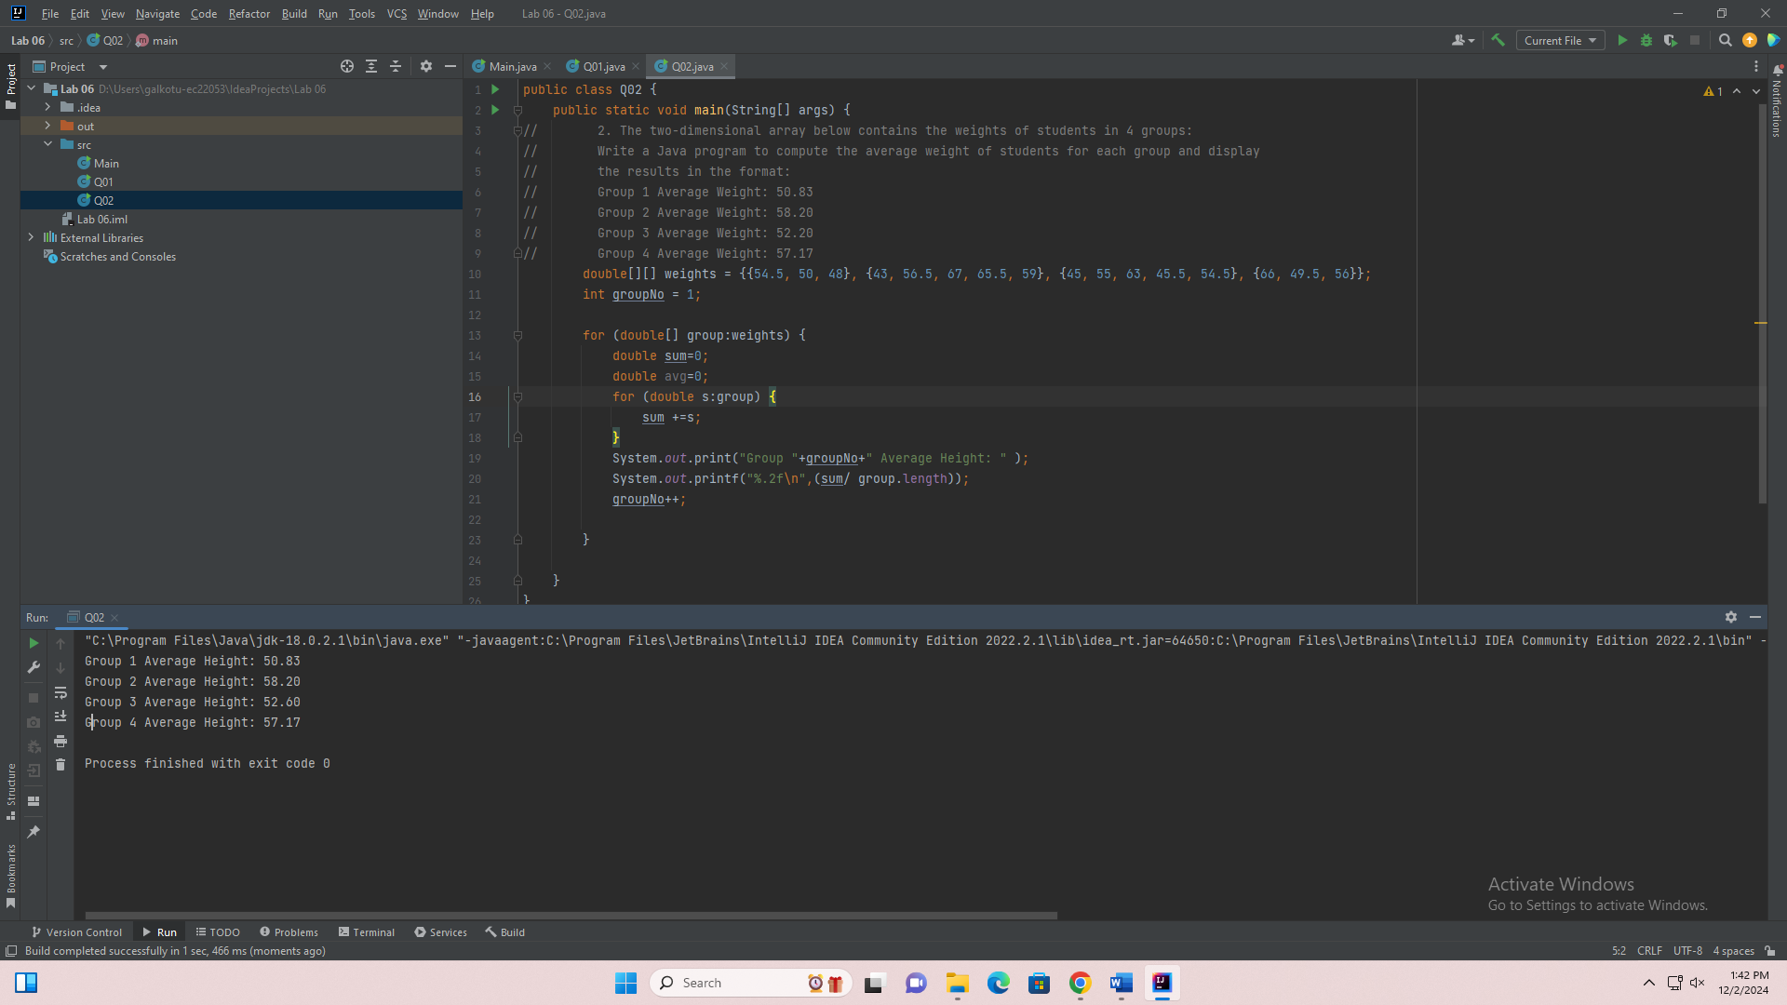

Q03.

public class Q03 {  
 public static void main(String[] args) {  
  
 String[][] nameRowList = {{"Amali", "Thilina", "Vihara"}, {"Kamal", "Nimal", "Sunil"}};  
 System.*out*.println("Seat No Student");  
 System.*out*.println("_______ _______");  
 int rowNo = 1;  
 int colNo = 1;  
 for (String[] first : nameRowList) {  
 for (String names : first) {  
 System.*out*.println(rowNo +""+ colNo+" "+"\t\t"+names);  
 colNo++;  
 }  
 colNo = 1;  
 rowNo++;  
 }  
 }  
}

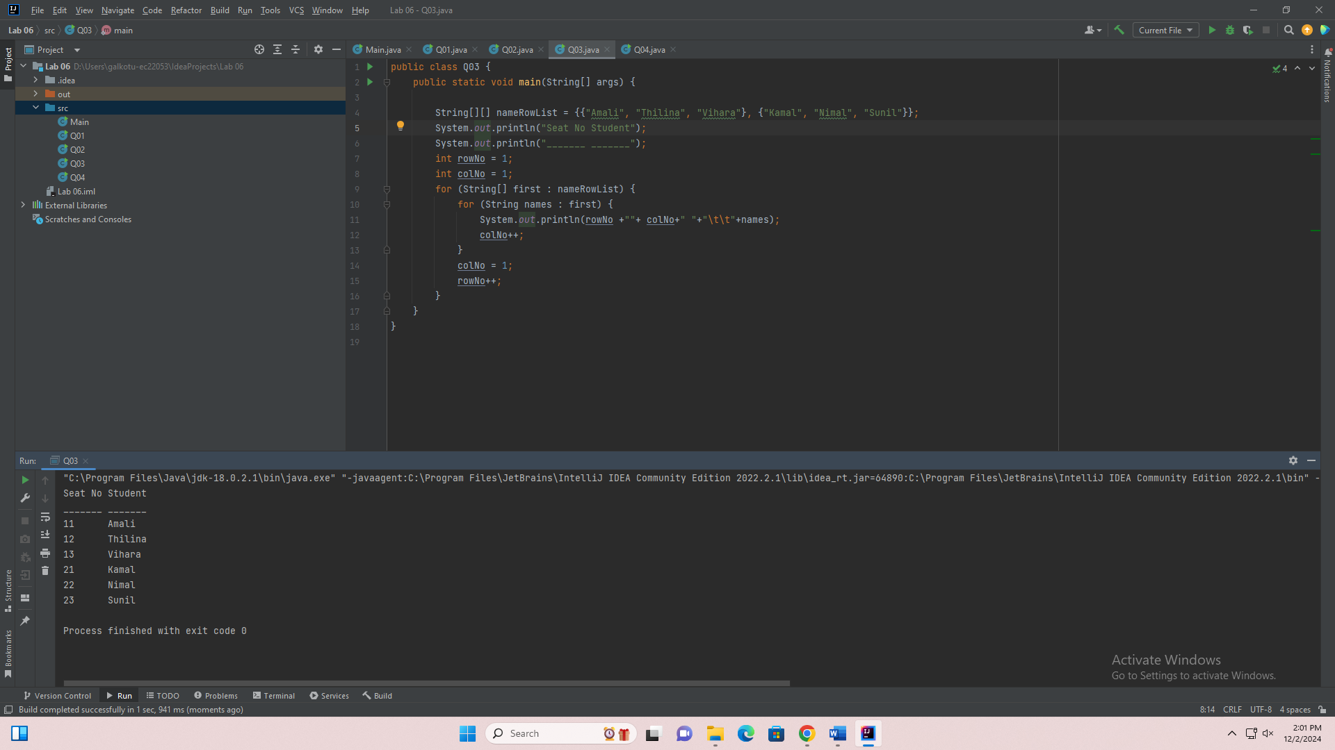

Q04

import java.util.Scanner;  
  
public class Q04 {  
 public static void main(String[] args) {  
  
   
 Scanner newScanObj = new Scanner(System.*in*);  
  
 System.*out*.println("Input the string in this form: december 8, 2024");  
   
 // Read the input line from the user  
 String dateLine = newScanObj.nextLine();  
 // Trim any leading or trailing whitespace from the input  
 dateLine = dateLine.trim();  
 // Find the position of the first space (separates month from day) and the first comma (separates day from year)  
 int firstSpace = dateLine.indexOf(" ");  
 int firstComma = dateLine.indexOf(",");  
 // Extract the month substring from the input string (from the start to the first space)  
 String fStr = dateLine.substring(0, firstSpace);  
 // Extract the day substring from the input string (between the space and the comma)  
 String secStr = dateLine.substring(firstSpace + 1, firstComma);  
 // Extract the year substring from the input string (after the comma)  
 String thirdStr = dateLine.substring(firstComma + 2);  
 // Get the first character of the month and convert it to uppercase  
 char monthFirstCharPosition = fStr.charAt(0);  
 String monthFirstChar = Character.*toString*(monthFirstCharPosition).toUpperCase();  
 // Convert the remaining part of the month to lowercase  
 String monthOther = fStr.substring(1).toLowerCase();  
 // Combine the uppercase first letter and the rest of the lowercase month  
 String month = monthFirstChar + monthOther;  
 // Ensure that the day string has two digits by adding a leading zero if necessary  
 String dateNo = (secStr.length() < 2 ? "0" + secStr : secStr);  
 // Print the date in the required format: "year month day"  
 System.*out*.println(thirdStr + " " + month + " " + dateNo);  
 }  
}

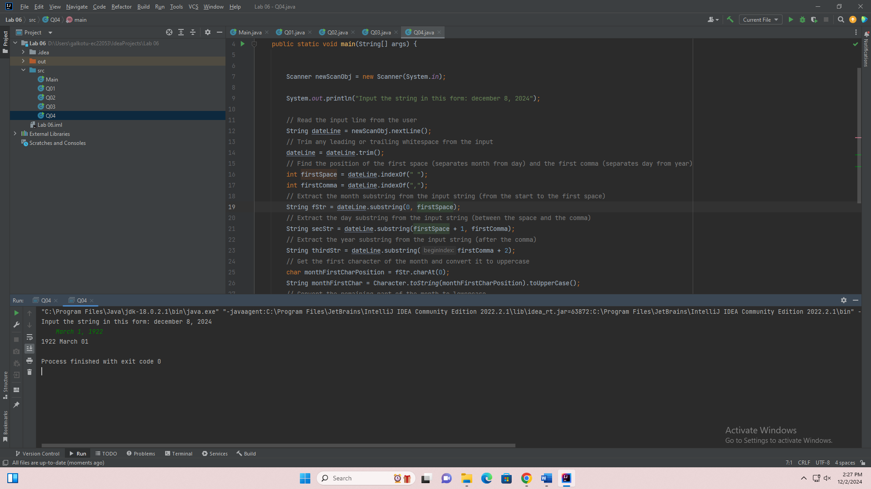

Q05.

import java.util.Scanner;  
  
public class Q05 {  
 public static void main(String[] args) {  
// Write a Java program to order two user input strings lexicographically. Sample input and  
// output are given below:  
//  
 System.*out*.println("Enter first String: ");  
 Scanner scanObj = new Scanner(System.*in*);  
 String fString = scanObj.nextLine();  
 System.*out*.println("Enter second String: ");  
 String secString = scanObj.nextLine();  
  
String Ordered = (fString.compareTo(secString) <0? fString + ", "+secString:secString + ", "+fString);  
 System.*out*.println(Ordered);  
  
 }  
  
}

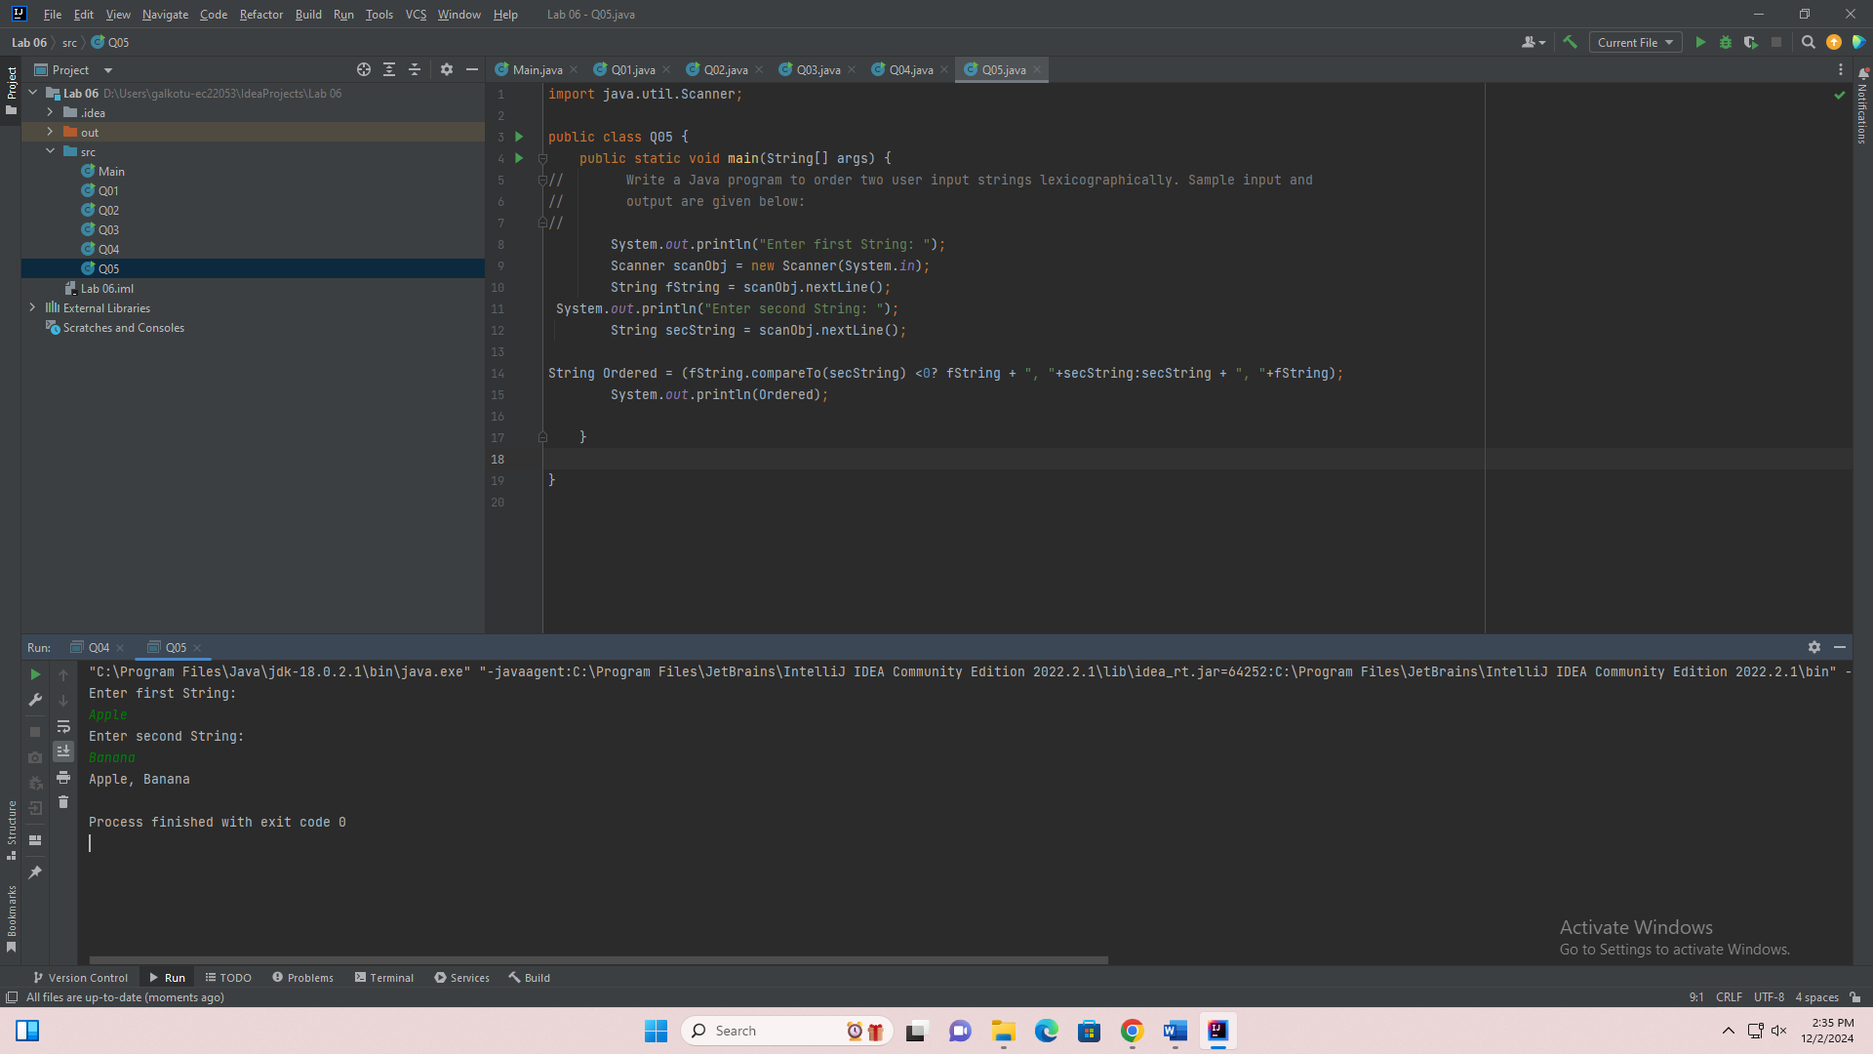

Q06

import java.util.Scanner;  
public class Q06 {  
 public static void main(String[] args) {  
 Scanner scanner = new Scanner(System.*in*);  
 System.*out*.print("Enter your Name: ");  
 String name = scanner.nextLine();  
 System.*out*.print("Enter your Age: ");  
 int age = scanner.nextInt();  
 scanner.nextLine();  
 System.*out*.print("Enter your Gender: ");  
 String gender = scanner.nextLine();  
 System.*out*.print("Enter your Weight in kilograms: ");  
 double weight = scanner.nextDouble();  
 System.*out*.print("Enter your Height in meters: ");  
 double height = scanner.nextDouble();  
 double bmi = (double) weight / (height*height);  
 String category;  
 if (bmi < 18.5) {  
 category = "Underweight";  
 } else if (bmi >= 18.5 && bmi < 24.9) {  
 category = "Normal weight";  
 } else if (bmi >= 25 && bmi < 29.9) {  
 category = "Overweight";  
 } else {  
 category = "Obesity";  
 }  
 // Print the result  
 System.*out*.println("\nHi " + name + "!");  
 System.*out*.println("Here are your details:");  
 System.*out*.println("Age: " + age);  
 System.*out*.println("Gender: " + gender);  
 System.*out*.println("Weight: " + weight + " kg");  
 System.*out*.println("Height: " + height + " m");  
 System.*out*.println("BMI: " + String.*format*("%.2f", bmi)); // Format BMI to 2 decimal places  
 System.*out*.println("Category: " + category);  
 }  
}

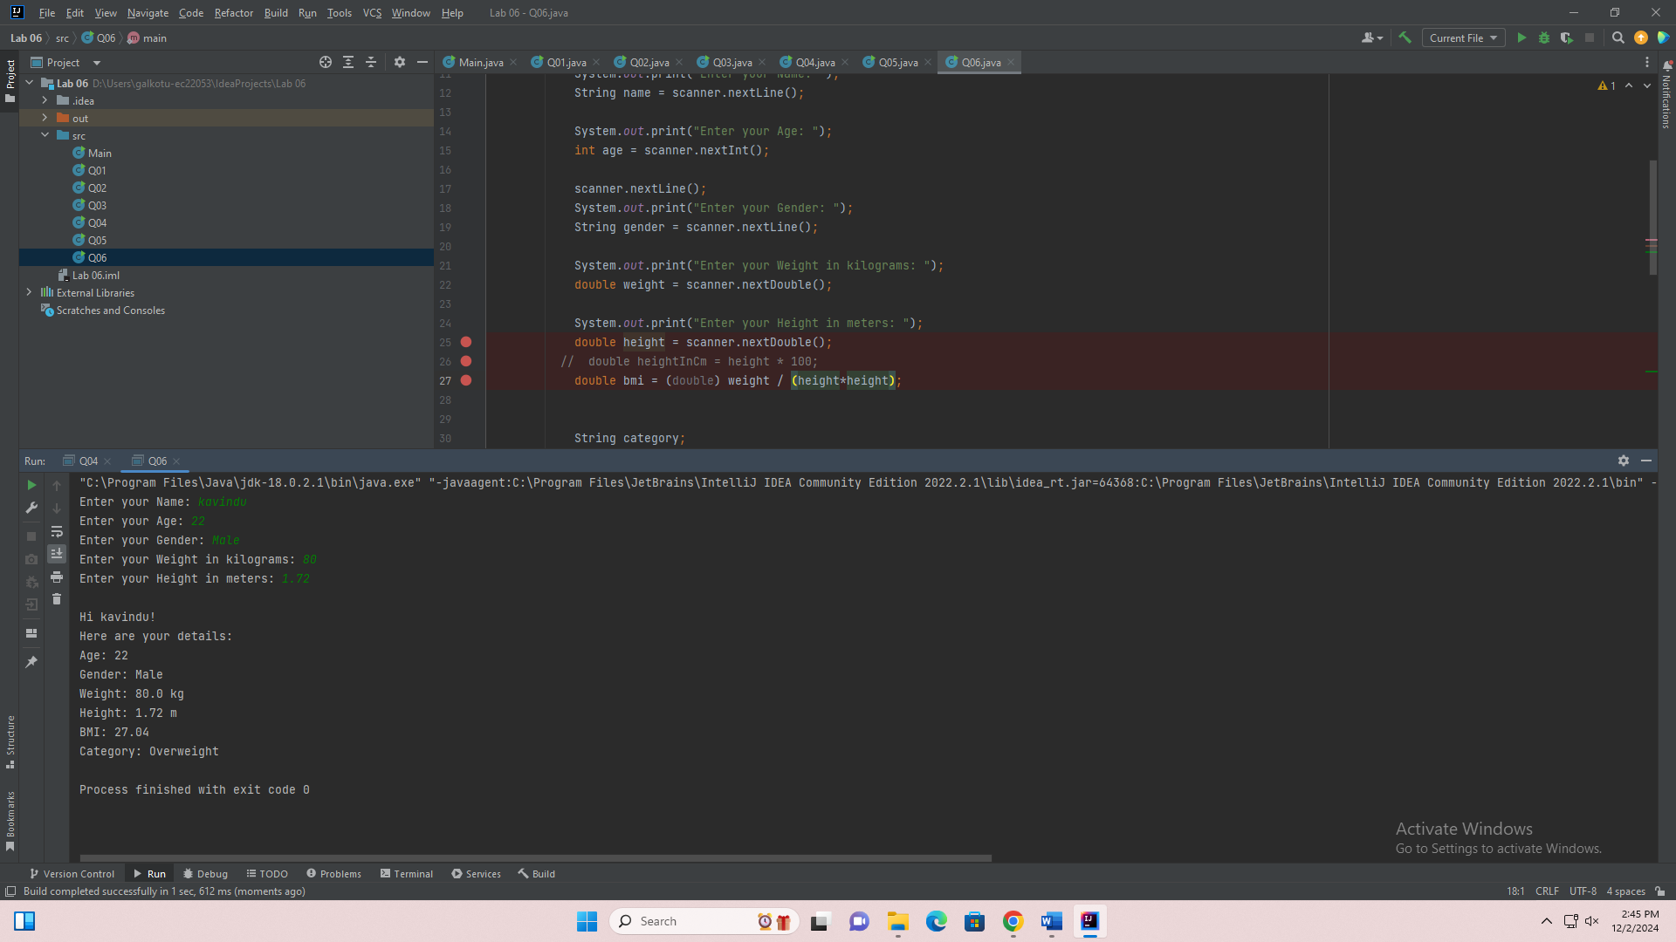

Q07.

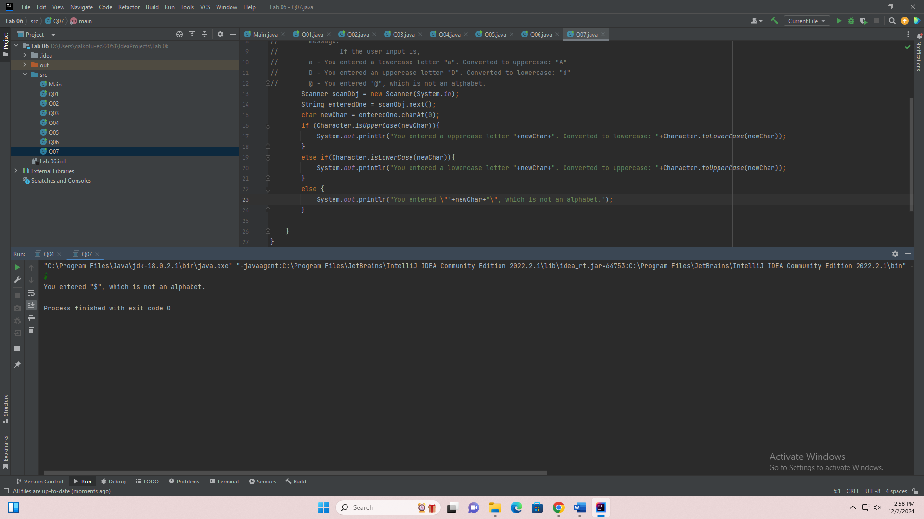

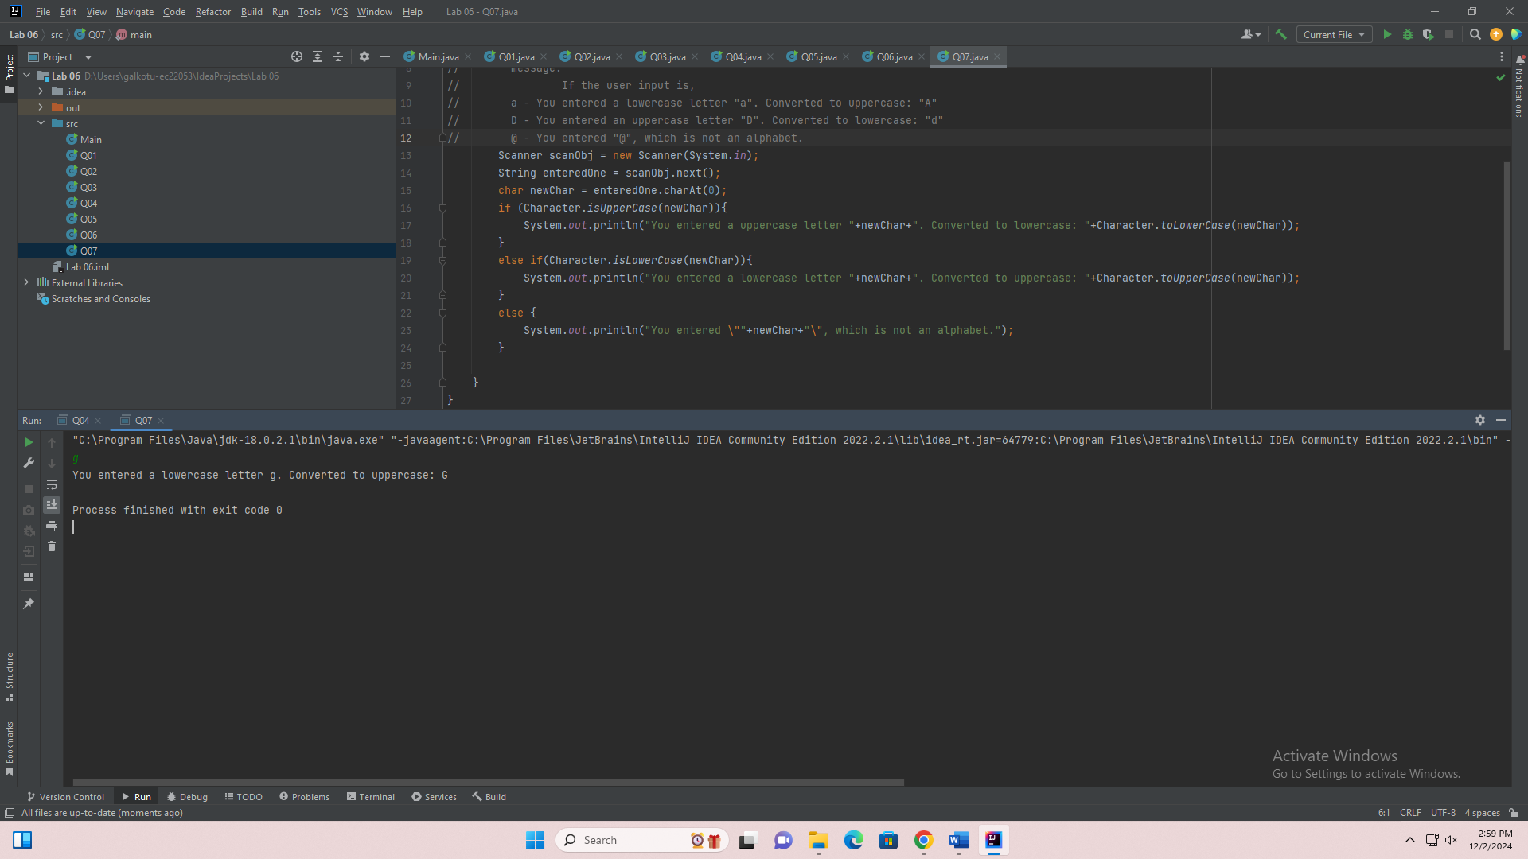

import java.util.Scanner;  
  
public class Q07 {  
 public static void main(String[] args) {  
// Write a program to check whether the entered character is a lowercase letter (a to z) or an  
// uppercase letter (A to Z). If the character is lowercase, convert it to uppercase. If it is  
// uppercase, convert it to lowercase. If the input is not an alphabet, display an appropriate  
// message.  
// If the user input is,  
// a - You entered a lowercase letter "a". Converted to uppercase: "A"  
// D - You entered an uppercase letter "D". Converted to lowercase: "d"  
// @ - You entered "@", which is not an alphabet.  
 Scanner scanObj = new Scanner(System.*in*);  
 String enteredOne = scanObj.next();  
 char newChar = enteredOne.charAt(0);  
 if (Character.*isUpperCase*(newChar)){  
 System.*out*.println("You entered a uppercase letter "+newChar+". Converted to lowercase: "+Character.*toLowerCase*(newChar));  
 }  
 else if(Character.*isLowerCase*(newChar)){  
 System.*out*.println("You entered a lowercase letter "+newChar+". Converted to uppercase: "+Character.*toUpperCase*(newChar));  
 }  
 else {  
 System.*out*.println("You entered \""+newChar+"\", which is not an alphabet.");  
 }  
  
 }  
}

Q08.

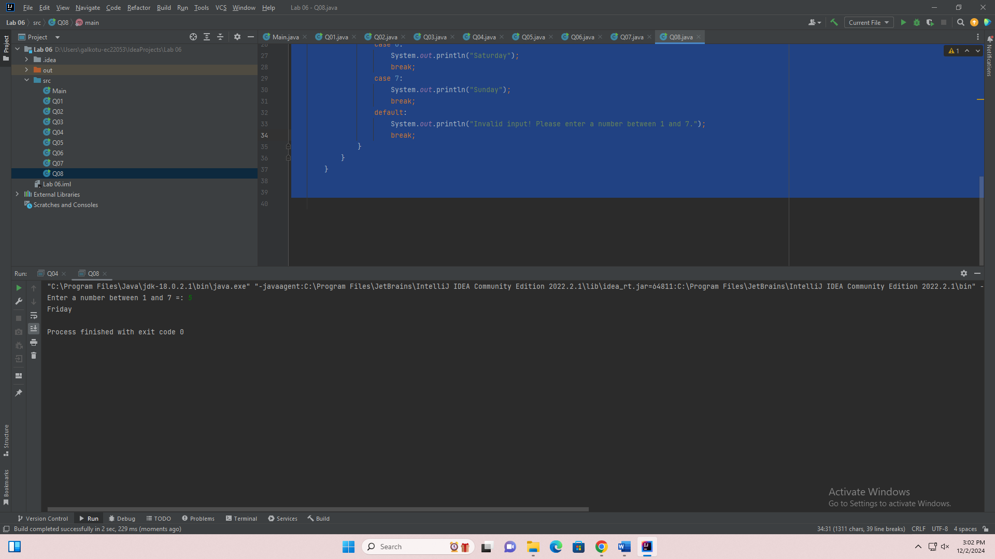

import java.util.Scanner;  
public class Q08 {  
 public static void main(String[] args) {  
  
  
 Scanner scanner = new Scanner(System.*in*);  
  
 System.*out*.print("Enter a number between 1 and 7 =: ");  
 int day = scanner.nextInt();  
 switch (day) {  
 case 1:  
 System.*out*.println("Monday");  
 break;  
 case 2:  
 System.*out*.println("Tuesday");  
 break;  
 case 3:  
 System.*out*.println("Wednesday");  
 break;  
 case 4:  
 System.*out*.println("Thursday");  
 break;  
 case 5:  
 System.*out*.println("Friday");  
 break;  
 case 6:  
 System.*out*.println("Saturday");  
 break;  
 case 7:  
 System.*out*.println("Sunday");  
 break;  
 default:  
 System.*out*.println("Invalid input! Please enter a number between 1 and 7.");  
 break;  
 }  
 }  
 }

Q09.

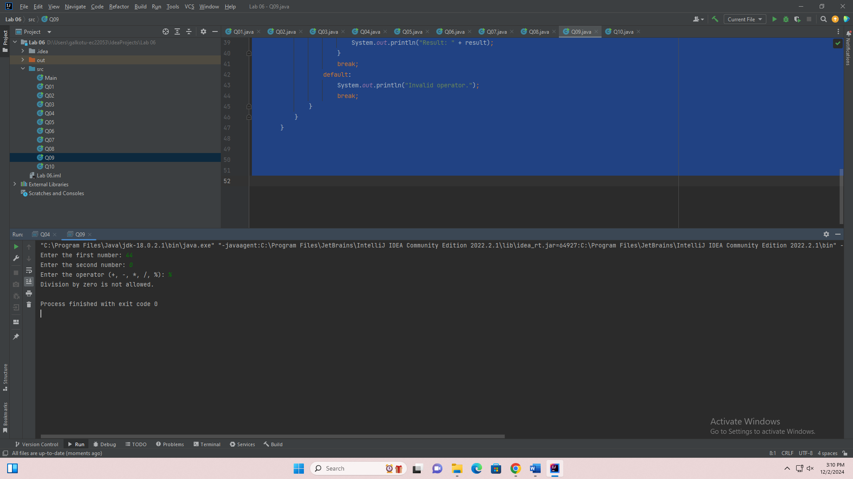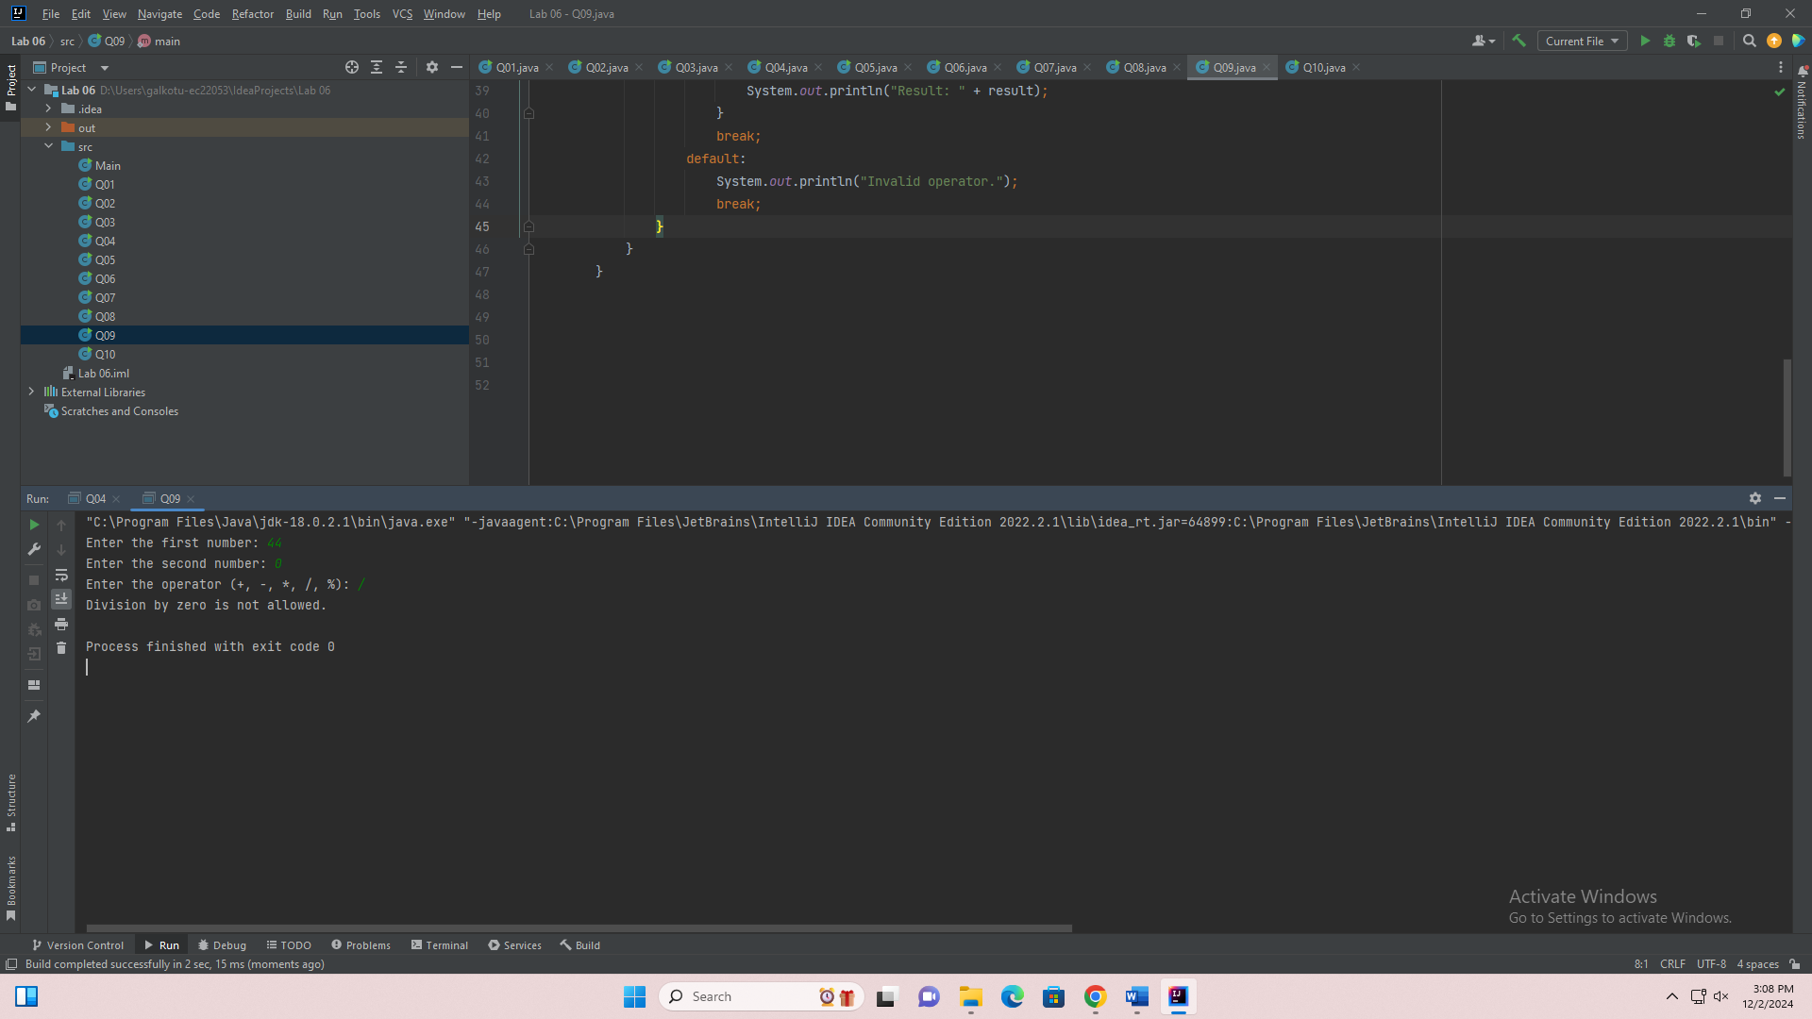

import java.util.Scanner;  
public class Q09 {  
 public static void main(String[] args) {  
 Scanner scanner = new Scanner(System.*in*);  
 System.*out*.print("Enter the first number: ");  
 double num1 = scanner.nextDouble();  
 System.*out*.print("Enter the second number: ");  
 double num2 = scanner.nextDouble();  
 System.*out*.print("Enter the operator (+, -, *, /, %): ");  
 char operator = scanner.next().charAt(0);  
 double result;  
 switch (operator) {  
 case '+':  
 result = num1 + num2;  
 System.*out*.println("Result: " + result);  
 break;  
 case '-':  
 result = num1 - num2;  
 System.*out*.println("Result: " + result);  
 break;  
 case '*':  
 result = num1 * num2;  
 System.*out*.println("Result: " + result);  
 break;  
 case '/':  
 if (num2 == 0) {  
 System.*out*.println("Division by zero is not allowed.");  
 } else {  
 result = num1 / num2;  
 System.*out*.println("Result: " + result);  
 }  
 break;  
 case '%':  
 if (num2 == 0) {  
 System.*out*.println("Division by zero is not allowed.");  
 } else {  
 result = num1 % num2;  
 System.*out*.println("Result: " + result);  
 }  
 break;  
 default:  
 System.*out*.println("Invalid operator.");  
 break;  
 }  
 }  
 }

Q10.

public class Q10 {  
 public static void main(String[] args) {  
// Write a Java program using a while loop to add the first 100 integers.  
// 5050  
int i = 1;  
int sum = 0;  
while (i<=100){  
 sum+=i;i++;  
}  
 System.*out*.println("The sum of the first 100 integers is: "+sum);  
 }  
}

